**Code Guard: Log Security Suite**

**Made to protect your Integrity**

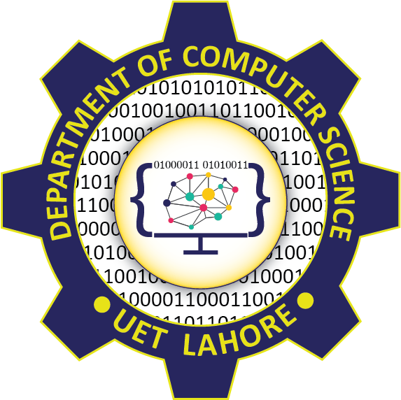

**Submitted by:**

Faaez Usmani 2022-CS-836

Shan Malik 2022-CS-830

Usman Naseer 2022-CS-825

Raheel Anjum 2022-CS-810

**Submitted To:**

Dr. Faiza Mehmood

Department of Computer Science

**University of Engineering and Technology**

**Lahore Pakistan**

Contents

1. Introduction 2

2. Project Features 2

• Log Analysis: 2

• Error and Warning Detection 2

• Encryption and Decryption: 3

• User Interaction: 3

• Customization and Flexibility: 3

• Documentation and Reporting: 3

3. Technology and Resources 3

• Bash Scripting: 3

• OpenSSL: 3

• Command-Line Interface (CLI): 4

• Text Processing Tools: 4

• Version Control: 4

• Documentation Tools: 4

• Development Environment: 4

# Introduction

In today's digital age, the effective management and security of data are paramount concerns for organizations across various industries. As the volume of digital information continues to grow exponentially, the need for robust tools and techniques to analyze logs and protect sensitive data becomes increasingly crucial.

The Log Analysis and Encryption/Decryption Script project aims to address these challenges by providing a comprehensive solution for analyzing log files and securing data through encryption and decryption processes. This project combines two essential functionalities into a single script, offering users a versatile toolset for managing and safeguarding their data assets.

The primary objective of the project is to develop a set of Bash scripts leveraging common command-line tools such as grep and OpenSSL to perform log analysis and data encryption/decryption tasks efficiently. By automating these processes, the scripts enable users to streamline their workflow, identify critical events in log files, and protect sensitive information from unauthorized access.

Through this project, users can gain insights into the health and performance of their systems by analyzing log files for error messages, warnings, and critical events. Additionally, they can enhance the security of their data by encrypting files using strong encryption algorithms and securely decrypting them when needed.

The Log Analysis and Encryption/Decryption Script project offers a versatile and user-friendly solution for managing log data and protecting sensitive information, contributing to improved data integrity, confidentiality, and overall cybersecurity posture.

# Project Features

## Log Analysis:

The project provides functionality to analyze log files for error messages, warnings, and critical events. Users can identify and extract critical information from log files using predefined patterns and keywords.

The script automates the process of parsing log files and generating summary reports to provide insights into system health and performance.

* Error and Warning Detection:

Users can detect and count the occurrences of error messages and warnings within log files. The script categorizes and prioritizes error and warning messages based on their frequency and severity.

By analyzing error and warning trends, users can identify potential issues and take proactive measures to address them before they escalate.

## Encryption and Decryption:

The project offers encryption and decryption functionality to protect sensitive data stored in files. Users can encrypt files using strong encryption algorithms such as AES-256-CBC to safeguard them from unauthorized access.

Encrypted files can be securely decrypted using the appropriate encryption key, ensuring data confidentiality is maintained throughout the process.

## User Interaction:

The script provides a user-friendly interface with menu options for selecting desired functionalities. Users can interact with the script through command-line prompts, enabling easy execution of log analysis and encryption/decryption tasks.

Clear instructions and prompts guide users through the process, making it accessible to individuals with varying levels of technical expertise.

## Customization and Flexibility:

The project allows users to customize log analysis parameters and encryption settings to suit their specific requirements. Users can define custom search patterns, keywords, and encryption keys based on their unique use cases and security needs.

The script is designed to be modular and extensible, enabling future enhancements and integration with additional functionalities.

## Documentation and Reporting:

The project includes comprehensive documentation outlining installation instructions, usage guidelines, and troubleshooting tips. Users can generate detailed summary reports summarizing the results of log analysis and encryption/decryption operations.

The reports provide valuable insights and actionable recommendations to help users make informed decisions and improve system security and performance.

# Technology and Resources

## Bash Scripting:

The project's core functionalities, including log analysis, encryption, and decryption, are implemented using Bash scripting.

Bash provides a powerful scripting environment for automating tasks, interacting with system resources, and processing text-based data.

## OpenSSL:

OpenSSL is a widely used open-source cryptographic library that provides various encryption and decryption algorithms.

The project leverages OpenSSL for encrypting and decrypting files using the AES-256-CBC cipher, ensuring data confidentiality and integrity.

## Command-Line Interface (CLI):

The project features a command-line interface that enables users to interact with the script and execute desired functionalities.

CLI allows users to input commands, options, and parameters directly from the terminal, facilitating seamless execution of tasks without the need for a graphical user interface.

## Text Processing Tools:

The project utilizes text processing tools such as grep, awk, and wc for parsing log files, searching for specific patterns, and extracting relevant information.

These tools enable efficient analysis of log data, identification of error and warning messages, and generation of summary reports.

## Version Control:

Version control systems like Git are employed to manage project source code, track changes, and collaborate with team members.

Git enables developers to maintain a centralized repository of project files, manage branches for feature development, and merge changes seamlessly.

## Documentation Tools:

Documentation tools like Markdown and plain text editors are utilized to create project documentation, including README files, usage guides, and technical specifications.

Markdown provides a simple and lightweight markup language for formatting text, creating lists, and embedding code snippets within documentation files.

## Development Environment:

The development environment consists of a Unix-like operating system (e.g., Linux, macOS) equipped with necessary command-line utilities and development tools.

Text editors or integrated development environments (IDEs) such as Vim, Emacs, or Visual Studio Code are used for writing and editing Bash scripts and documentation files.